**Topics: Normal distribution, Functions of Random Variables**

1. The time required for servicing transmissions is normally distributed with *μ* = 45 minutes and *σ* = 8 minutes. The service manager plans to have work begin on the transmission of a customer’s car 10 minutes after the car is dropped off and the customer is told that the car will be ready within 1 hour from drop-off. What is the probability that the service manager cannot meet his commitment?
2. 0.3875
3. 0.2676
4. 0.5
5. 0.6987

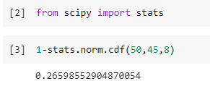

1. The current age (in years) of 400 clerical employees at an insurance claims processing center is normally distributed with mean *μ* = 38 and Standard deviation *σ* =6. For each statement below, please specify True/False. If false, briefly explain why.
2. More employees at the processing center are older than 44 than between 38 and 44.

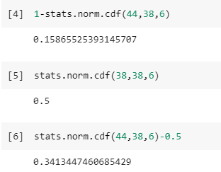

**So, the probability that the employee will be greater than age of 44 = 15%**

**Now, the probability of number of employees between 38-44 years of age =**

**Pr(X<44) - 0.5 = 0.84 - 0.5= 34%**

**Therefore, the statement that “More employees at the processing center are older**

**than 44 than between 38 and 44” is False.**

1. A training program for employees under the age of 30 at the center would be vexpected to attract about 36 employees.

**So, the number of employees with probability 0.912 of them being under age 30 =**

**0.0912*400=36.48(36 employees).**

**Therefore, the statement B of the question is TRUE**.

1. If *X1* ~ *N*(μ, σ2) and *X*2 ~ *N*(μ, σ2) are *iid* normal random variables, then what is the difference between 2 *X*1 and *X*1 + *X*2? Discuss both their distributions and parameters.

**As we know that if X ∼ N (µ1, σ1^2), and Y ∼ N (µ2, σ2^2) are two independents**

**random variables then X + Y ∼ N (µ1 + µ2, σ1^2 + σ2^2), and X − Y ∼ N (µ1 − µ2, σ1^2 +**

**σ2^2).**

**Similarly, if Z = aX + bY, where X and Y are as defined above, i.e Z is linear combination of X**

**and Y, then Z ∼ N (aµ1 + bµ2, a^2σ1^2 + b^2σ2^2).**

**Therefore, in the question**

**2X1~ N (2 u,4 σ^2) and**

**X1+X2 ~ N (µ + µ, σ^2 + σ^2) ~ N (2 u, 2σ^2)**

**2X1-(X1+X2) = N (4µ,6 σ^2)**

1. Let X ~ N(100, 202). Find two values, *a* and *b*, symmetric about the mean, such that the probability of the random variable taking a value between them is 0.99.
2. 90.5, 105.9
3. 80.2, 119.8
4. 22, 78
5. 48.5, 151.5
6. 90.1, 109.9

**Since we need to find out the values of a and b, which are symmetric about the**

**mean, such that the probability of random variable taking a value between them is**

**0.99, we must work out in reverse order.**

**The Probability of getting value between a and b should be 0.99.**

**So, the Probability of going wrong, or the Probability outside the a and b area is 0.01**

**(i.e., 1-0.99).**

**The Probability towards left from a = -0.005 (i.e., 0.01/2).**

**The Probability towards right from b = +0.005 (i.e., 0.01/2).**

**So, since we have the probabilities of a and b, we need to calculate X, the random**

**variable at a and b which has got these probabilities.**

**By finding the Standard Normal Variable Z (Z Value), we can calculate the X values.**

**Z= (X- μ) / σ**

**For Probability 0.005 the Z Value is -2.57 (from Z Table).**

**Z * σ + μ = Xe**

**Z (-0.005) *20+100 = -(-2.57) *20+100 = 151.5**

**Z (+0.005) *20+100 = (-2.57) *20+100 = 48.6**

**So, option D is correct.**

1. Consider a company that has two different divisions. The annual profits from the two divisions are independent and have distributions Profit1 ~ N(5, 32) and Profit2 ~ N(7, 42) respectively. Both the profits are in $ Million. Answer the following questions about the total profit of the company in Rupees. Assume that $1 = Rs. 45
2. Specify a Rupee range (centered on the mean) such that it contains 95% probability for the annual profit of the company.

**Total profit is Profit1 + profit2 = N (5+7,3 +4 2) = N (12,7 2)**

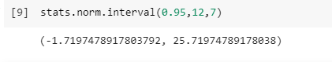

1. Specify the 5th percentile of profit (in Rupees) for the company

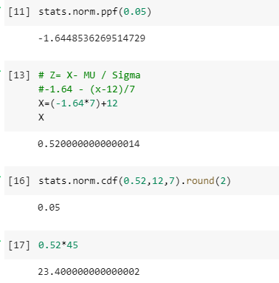

**Hence the 5th percentile of Profit (in Rupees) is = 23.4**

1. Which of the two divisions has a larger probability of making a loss in a given year?

**There is less loss difference but still company1 is having more probability of making a loss.**

